**Healthy Diet**

The human physique is designed for certain necessities and functions and food plays a main role in driving them. In nutrition, **diet** is the amount of food consumed by a individual or other organism.  Along with what we consume, it is also important to identify how to eat and when to eat.

[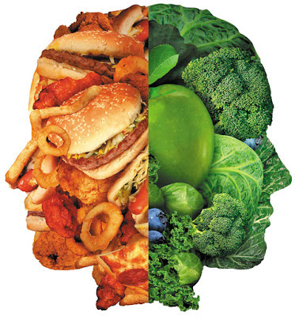](https://4.bp.blogspot.com/-MW3hy5ywyT4/W8v3yDXyz_I/AAAAAAAAAYc/QKk8fizxwZE7JRrOID7FzqBab_Yz3qmAgCLcBGAs/s1600/p6_BadFoodGoodFood_HL1801_dt52432050.jpg)

Social norms, customs and food limitations all effect our diet. So do diets that are grown locally or else. A diet graph if followed, must be supplemented with a good workout plan that would provide balance between inner immune system and health. A great protein diet **(40%-50%)** is difficult to digest and therefore, workout is essential. **Here is brief diet idea:**

* Cook for yourself too

[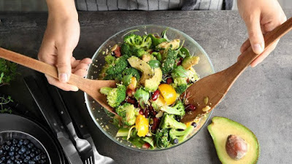](https://4.bp.blogspot.com/-bEIoB9hOJNo/W8v4OFlVK7I/AAAAAAAAAYk/7lidOCQps_EEMj1DEt50eUbn4GLu_sEEACLcBGAs/s1600/cs-Simple-Tips-for-Your-Diabetes-Diet-1440x810.jpg)

Housewives typically cook much-loved foods of husbands and children. Do not provide importance to their choice of food. But housewives must start cooking themselves for keeping weight in control and healthy eating behaviours.

* Get the opportunity to move the body

[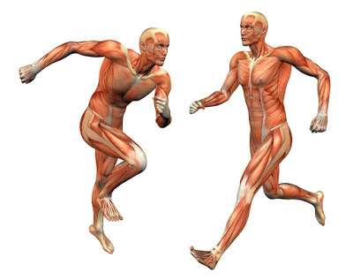](https://2.bp.blogspot.com/-6qeersBKIio/W8v4ZI9u6DI/AAAAAAAAAYo/z-2eq32kbBEmn5BKT_tzWvIJyFccyJhiwCLcBGAs/s1600/MuscleManRunning-1024x813.jpg)

Though you are stuck in the house all day, you can burn certain calories. That is why you have to do the effort of the physique as you can dance. Or you can come out in the botanical gardens a little bit.

* Make most of your meal vegetable and fruit

[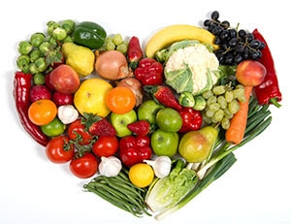](https://1.bp.blogspot.com/-NyLiueodmuw/W8v4k-_MiCI/AAAAAAAAAYw/6mtT_AvEJz8p2JycGTtfXcGIfmv1sVhpwCLcBGAs/s1600/veggie-heart.jpg)

Aim for colour and diversity, and recall that potatoes don’t count as vegetables on the Healthy Eating Plate because of their bad effect on blood sugar.

* Day plan

**Breakfast** will benefit you start your day with plenty of energy. Don't collapse your brewith high-fat and high-calorie foods. Pick some protein and fibre for your breakfast, and it's a good time to eat some renewed fruit.

[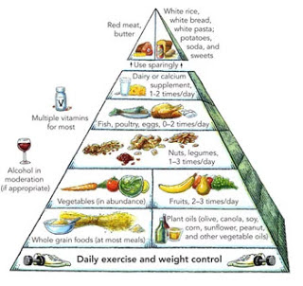](https://2.bp.blogspot.com/-UtN4FveNl7Q/W8v5Cfv3D7I/AAAAAAAAAZA/rMBlxnmlocog6PfEXr4IMd9-Mgm5pWNlwCLcBGAs/s1600/healthy-eating-pyramid-350%2B%25281%2529.jpg)

**Lunch** is frequently something you eat at work or school, so it's a great period to pack a sandwich or leftovers that you can heat and heat. Or, if you purchase your lunch, choose a healthy strong soup or renewed veggie salad.

In **dinner** seal half your plate with a colourful diversity of vegetables or salad, drizzle with a dressing made from linseed or rapeseed oil and enhance meat, fish or beans with a serving of brown rice, quinoa or entire meal pasta.

* Refresh Meal Plan

If you identify that if you make a large dinner in Arizona, then design breakfast and lunch. You have to find out how many calories you eat at feast. Consequently calculate the calorie target for the day. The housewives must eat food cautiously so that the weight does not rise.

* Foods to be avoided

[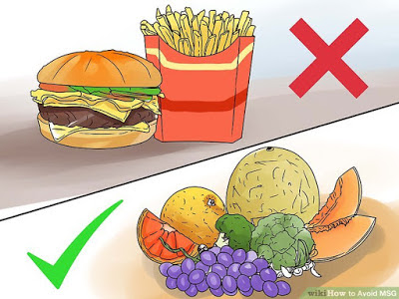](https://1.bp.blogspot.com/-1wwsmJfbOTI/W8v5UFBVbzI/AAAAAAAAAZI/CHuqHyHi4a0Q13z6S897GKK6U4EqSJFiACLcBGAs/s1600/aid1536636-v4-728px-Avoid-MSG-Step-2-Version-2.jpg)

* Jams, fruit reserves with sugar
* Mango, banana and grapes, Custard Apple
* Additional cream, processed cheese, butter and oil
* Extra fried foods like poories, paranthas, pakoras and samosas
* Extra rice and rice products
* Potato, sweet potato, arbi (colocasia) and jimikand (yam)
* Alcohol ,Aerated drinks